#
# Print awailable link on network interfaces.
#

# For 6.x systems.
[root@m1-sasetl01p 20190621]# for var1 in $(ifconfig -a | grep Link | awk '{ printf $1" " }') ; do printf "${var1}\t" ; ethtool ${var1} | grep -ie "Link detected" ; done
bond0 Link detected: yes
bond1 Link detected: yes
eth0 Link detected: no
eth1 Link detected: no
eth2 Link detected: no
eth3 Link detected: no
eth4 Link detected: yes
eth4.1626 Link detected: yes
eth4.1765 Link detected: yes
eth5 Link detected: no
eth6 Link detected: yes
eth6.1626 Link detected: yes
eth6.1765 Link detected: yes
eth7 Link detected: no
eth8 Link detected: yes
eth9 Link detected: yes
lo Link detected: yes
[root@m1-sasetl01p 20190621]#

# For 7.x systems.
[root@m1-datagrid01p ~]# for var1 in $(ifconfig -a | grep flags= | awk '{ printf $1" " }') ; do printf "${var1}\t" ; ethtool ${var1} | grep -ie "Link detected" ; done
bond0: Link detected: yes
bond1: Link detected: yes
bond2: Link detected: yes
docker0: Link detected: no
em1: Link detected: yes
em2: Link detected: yes
em3: Link detected: no
em4: Link detected: no
em2.1626: Link detected: yes
em2.1764: Link detected: yes
lo: Link detected: yes
p4p1: Link detected: no
p4p2: Link detected: yes
p4p2.1626: Link detected: yes
p4p2.1764: Link detected: yes
[root@m1-datagrid01p ~]#

20161129
# How to see defined interface info, link statistics, routes.

[support@centos00 ~]$ ip -f inet addr show eth0
2: eth0: <BROADCAST,MULTICAST,UP,LOWER_UP> mtu 1500 qdisc pfifo_fast state UP qlen 1000
inet 10.0.2.15/24 brd 10.0.2.255 scope global eth0
[support@centos00 ~]$ ip -s link show eth0
2: eth0: <BROADCAST,MULTICAST,UP,LOWER_UP> mtu 1500 qdisc pfifo_fast state UP qlen 1000
link/ether 10:78:d2:53:73:c8 brd ff:ff:ff:ff:ff:ff
RX: bytes packets errors dropped overrun mcast
1290618357 19223178 0 0 0 0
TX: bytes packets errors dropped carrier collsns
1185326282 14209076 0 0 0 0
[support@centos00 ~]$ ip route show
10.0.2.0/24 dev eth0 proto kernel scope link src 10.0.2.15
169.254.0.0/16 dev eth0 scope link metric 1002
default via 10.0.2.2 dev eth0 proto static
[support@centos00 ~]$ ip neighbor show
10.0.2.2 dev eth0 lladdr 52:54:00:12:35:02 REACHABLE
[support@centos00 ~]$ ip n
10.0.2.2 dev eth0 lladdr 52:54:00:12:35:02 REACHABLE
[support@centos00 ~]$

#
# To down network interface.
ip link set dev eno6 down

#
# 20180913
# Get info about custom route.

# Exists suspected interfaces in VLAN 1747.
# They are here.
[root@m1-db12-prod ~]# ip -f inet addr | grep inet | grep 1747
inet 10.217.47.147/24 brd 10.217.47.255 scope global bond1.1747
inet 10.217.47.45/24 brd 10.217.47.255 scope global secondary bond1.1747:0
inet 10.217.47.156/24 scope global secondary bond1.1747:1
inet 10.217.47.179/24 scope global secondary bond1.1747:2
[root@m1-db12-prod ~]#

# Test custom rules. And see something named as 1747.
# For addresses belonged to network 10.217.47.0/24 is used custom route table named as 1747.
[root@m1-db12-prod ~]# ip rule list
0: from all lookup local
32765: from 10.217.47.0/24 lookup 1747
32766: from all lookup main
32767: from all lookup default
[root@m1-db12-prod ~]#

# Let’s see - what’s there.
# Here is a custom default gateway.
[root@m1-db12-prod ~]# ip route show table 1747
default via 10.217.47.254 dev bond1.1747
[root@m1-db12-prod ~]#

#
# The way to see more related with route with network 10.217.47.0/24.
[root@m1-db12-prod ~]# ip route show table all | grep -e "1747" | sort
10.217.47.0/24 dev bond1.1747 proto kernel scope link src 10.217.47.147
broadcast 10.217.47.0 dev bond1.1747 table local proto kernel scope link src 10.217.47.147
broadcast 10.217.47.255 dev bond1.1747 table local proto kernel scope link src 10.217.47.147
default via 10.217.47.254 dev bond1.1747 table 1747
local 10.217.47.147 dev bond1.1747 table local proto kernel scope host src 10.217.47.147
local 10.217.47.156 dev bond1.1747 table local proto kernel scope host src 10.217.47.147
local 10.217.47.179 dev bond1.1747 table local proto kernel scope host src 10.217.47.147
local 10.217.47.45 dev bond1.1747 table local proto kernel scope host src 10.217.47.147
[root@m1-db12-prod ~]#

#
# And other not too much useful.
#
# Here I see nothing interesting at all.
[root@m1-db12-prod ~]# cat /etc/iproute2/rt_tables
#
# reserved values
#
255 local
254 main
253 default
0 unspec
#
# local
#
#1 inr.ruhep
[root@m1-db12-prod ~]#

#
# Here I can see what bonding interface is used by interface name bond1.1747.
[root@m1-db12-prod ~]# cat /proc/net/vlan/bond1.1747
bond1.1747 VID: 1747 REORDER_HDR: 1 dev->priv_flags: 1
total frames received 33274080
total bytes received 29434874664
Broadcast/Multicast Rcvd 1

total frames transmitted 11741457
total bytes transmitted 84760711553
Device: bond1
INGRESS priority mappings: 0:0 1:0 2:0 3:0 4:0 5:0 6:0 7:0
EGRESS priority mappings:
[root@m1-db12-prod ~]#

#
# Here I can see mac address active physical interface used in bond1.
[root@m1-db12-prod ~]# cat /proc/net/bonding/bond1
Ethernet Channel Bonding Driver: v3.7.1 (April 27, 2011)

Bonding Mode: fault-tolerance (active-backup)
Primary Slave: None
Currently Active Slave: em2
MII Status: up
MII Polling Interval (ms): 100
Up Delay (ms): 0
Down Delay (ms): 0

Slave Interface: em2
MII Status: up
Speed: 10000 Mbps
Duplex: full
Link Failure Count: 0
Permanent HW addr: d0:94:66:09:60:7a
Slave queue ID: 0

Slave Interface: p5p2
MII Status: up
Speed: 10000 Mbps
Duplex: full
Link Failure Count: 0
Permanent HW addr: f4:e9:d4:d0:5e:52
Slave queue ID: 0
[root@m1-db12-prod ~]#

#
# Here I can get some statistics about physical interface em2.
[root@m1-db12-prod ~]# ip -s link show em2
3: em2: <BROADCAST,MULTICAST,SLAVE,UP,LOWER_UP> mtu 9000 qdisc mq master bond1 portid d0946609607a state UP mode DEFAULT qlen 1000
link/ether d0:94:66:09:60:7a brd ff:ff:ff:ff:ff:ff
RX: bytes packets errors dropped overrun mcast
221058113921736 36499938687 0 1027 0 53
TX: bytes packets errors dropped carrier collsns
166935158142085 36509979974 0 0 0 0
[root@m1-db12-prod ~]#

# This is for rhel 7, centos 7, fedora.
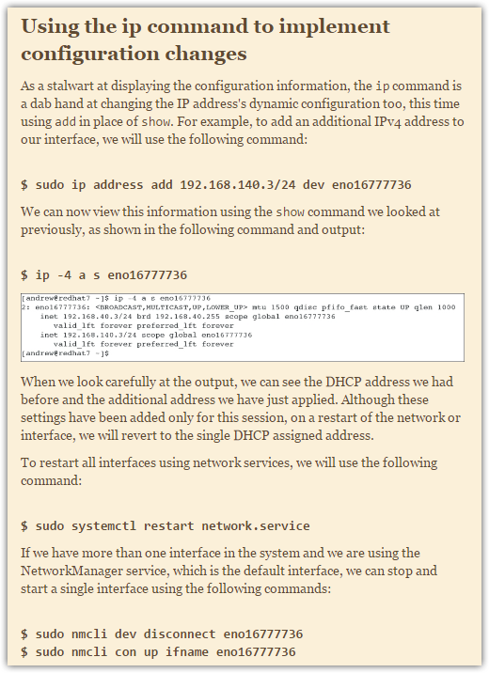

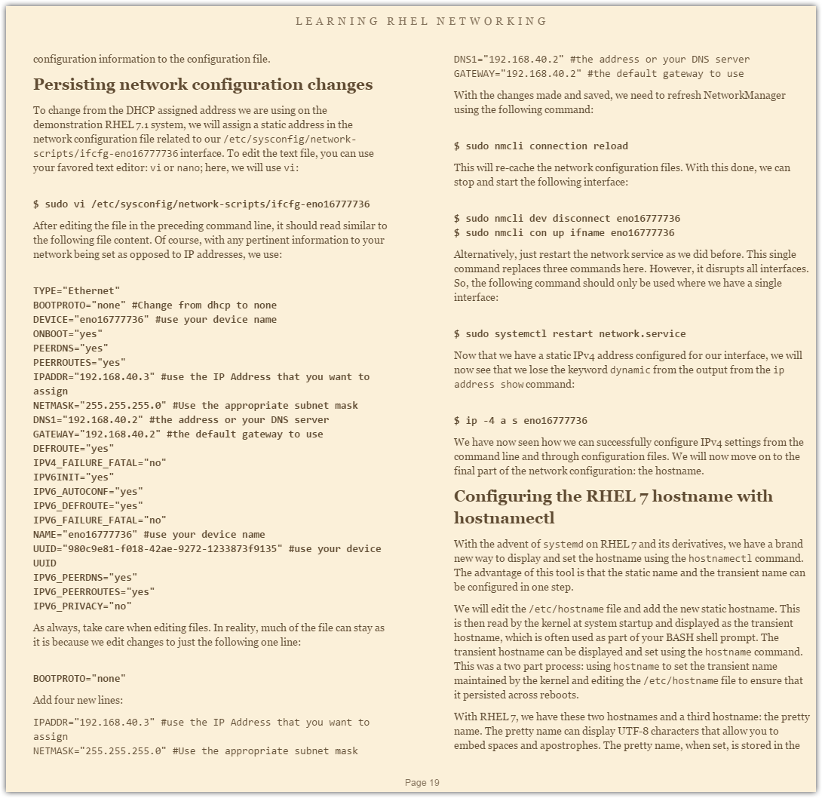

# 20170804
# How to make route to defined network. An example.
#
[root@m1-2-gp-prd-mdw ~]# cat /etc/rc.local
#!/bin/sh
#
# This script will be executed *after* all the other init scripts.
# You can put your own initialization stuff in here if you don't
# want to do the full Sys V style init stuff.

touch /var/lock/subsys/local

echo never > /sys/kernel/mm/redhat_transparent_hugepage/defrag
echo never > /sys/kernel/mm/redhat_transparent_hugepage/enabled
/sbin/blockdev --setra 16385 /dev/sda
/sbin/blockdev --setra 16385 /dev/sdb
/sbin/ip route add 10.216.2.0/24 via 10.216.4.254
[root@m1-2-gp-prd-mdw ~]#

20161021
# How to understand what route used by appropriate rule number.

[root@ds-db-tst ~]# ip rule list
0: from all lookup local
32738: from 10.217.53.193 lookup 103
32739: from 10.217.54.67 lookup 104
...

[root@ds-db-tst ~]# ip route show table all
default via 10.217.54.254 dev bond6 table 104
...

[root@ds-db-tst ~]# cat /etc/iproute2/rt_tables
#
# reserved values
#
255 local
254 main
253 default
0 unspec
#
# local
#
#1 inr.ruhep
[root@ds-db-tst ~]#

20161027
# To see link status.

[root@m1-instana-01t ~]# ip link
1: lo: <LOOPBACK,UP,LOWER_UP> mtu 65536 qdisc noqueue state UNKNOWN mode DEFAULT
link/loopback 00:00:00:00:00:00 brd 00:00:00:00:00:00
2: enp4s0f0: <BROADCAST,MULTICAST,UP,LOWER_UP> mtu 1500 qdisc pfifo_fast master team0 state UP mode DEFAULT qlen 1000
link/ether 78:e3:b5:0c:14:70 brd ff:ff:ff:ff:ff:ff
3: enp4s0f1: <BROADCAST,MULTICAST,UP,LOWER_UP> mtu 1500 qdisc pfifo_fast master team0 state UP mode DEFAULT qlen 1000
link/ether 78:e3:b5:0c:14:70 brd ff:ff:ff:ff:ff:ff
4: enp4s0f2: <NO-CARRIER,BROADCAST,MULTICAST,UP> mtu 1500 qdisc pfifo_fast state DOWN mode DEFAULT qlen 1000
link/ether 78:e3:b5:0c:14:72 brd ff:ff:ff:ff:ff:ff
5: enp4s0f3: <NO-CARRIER,BROADCAST,MULTICAST,UP> mtu 1500 qdisc pfifo_fast state DOWN mode DEFAULT qlen 1000
link/ether 78:e3:b5:0c:14:73 brd ff:ff:ff:ff:ff:ff
6: team0: <BROADCAST,MULTICAST,UP,LOWER_UP> mtu 1500 qdisc noqueue state UP mode DEFAULT
link/ether 78:e3:b5:0c:14:70 brd ff:ff:ff:ff:ff:ff
7: team0.1649@team0: <BROADCAST,MULTICAST,UP,LOWER_UP> mtu 1500 qdisc noqueue state UP mode DEFAULT
link/ether 6a:e2:83:23:fa:74 brd ff:ff:ff:ff:ff:ff
[root@m1-instana-01t ~]#

20160216
# How to see less uninteresting information.

[root@centos00 ~]# ip -f inet addr
1: lo: <LOOPBACK,UP,LOWER_UP> mtu 16436 qdisc noqueue state UNKNOWN
inet 127.0.0.1/8 scope host lo
2: eth0: <BROADCAST,MULTICAST,UP,LOWER_UP> mtu 1500 qdisc pfifo_fast state UP qlen 1000
inet 10.0.2.15/24 brd 10.0.2.255 scope global eth0
[root@centos00 ~]#

20151007
# Here is an example how to add static route to host.
[root@m1-gp-tst-smdw 20151005-1826]# route add -host 10.217.50.167 gw 10.216.0.254

route add default gw 10.216.27.254 eth8.1627

route del default gw 10.216.27.254 eth8.1627

[root@smdw_test tmp]# ip route list
10.216.27.0/24 dev eth9.1627 proto kernel scope link src 10.216.27.32
10.216.27.0/24 dev eth8.1627 proto kernel scope link src 10.216.27.34
192.168.253.0/24 dev eth1 proto kernel scope link src 192.168.253.5
192.168.254.0/24 dev eth0 proto kernel scope link src 192.168.254.5

[root@smdw_test tmp]# ip rule list
0: from all lookup local
32766: from all lookup main
32767: from all lookup default
[root@smdw_test tmp]#

ip route flush cache

ip addr list

[support@centos00 hq-msk-gp-tst]$ ip addr list
1: lo: <LOOPBACK,UP,LOWER_UP> mtu 16436 qdisc noqueue state UNKNOWN
link/loopback 00:00:00:00:00:00 brd 00:00:00:00:00:00
inet 127.0.0.1/8 scope host lo
2: eth0: <BROADCAST,MULTICAST,UP,LOWER_UP> mtu 1500 qdisc pfifo_fast state UP qlen 1000
link/ether 10:78:d2:53:73:c8 brd ff:ff:ff:ff:ff:ff
inet 10.0.2.15/24 brd 10.0.2.255 scope global eth0
[support@centos00 hq-msk-gp-tst]$ ip rule list
0: from all lookup local
32766: from all lookup main
32767: from all lookup default
[support@centos00 hq-msk-gp-tst]$ ip route list
10.0.2.0/24 dev eth0 proto kernel scope link src 10.0.2.15
169.254.0.0/16 dev eth0 scope link metric 1002
default via 10.0.2.2 dev eth0 proto static
[support@centos00 hq-msk-gp-tst]$
[root@centos00 ~]# ip route flush cache
[root@centos00 ~]#

http://sysadmins.ru/topic79707.html

xxx.xxx.xxx.xx5 (eth1), yyy.yyy.yyy.yy5 (eth2) - ваши внешние адреса соответственно первого и второго канала, а xxx.xxx.xxx.xx1 и yyy.yyy.yyy.yy1 - адреса провайдерских шлюзов. 192.168.0.0/16 (eth0) - ваша локальная сеть.
Предполагаем, что поумолчанию используется первый канал, т.е.

route add default gw xxx.xxx.xxx.xx1

Далее добавляем таблицу, редактируя файл /etc/iproute2/rt_tables, например, с именем toprov2 и номером 100.

>cat rt_tables
255 local
254 main
253 default
100 toprov2
0 unspec

описываем маршрутизацию в созданной таблице:

ip route add default via yyy.yyy.yyy.yy1 table toprov2

теперь весь трафик который пришел на интерфейс второго провайдера отправляет через этогоже провайдера:

ip rule add from yyy.yyy.yyy.yy5 dev eth2 table toprov2

теперь сбрасываем кэш

ip route flush cache

все должно работать.

[root@mdw_prod network-scripts]# route add -net 10.216.26.0/24 gw 10.216.26.254
[root@mdw_prod network-scripts]#

http://www.cyberciti.biz/tips/configuring-static-routes-in-debian-or-red-hat-linux-systems.html

Configure Static Routes In Debian or Red Hat Enterprise Linux
by NIX CRAFT on APRIL 13, 2006 · 36 COMMENTS· LAST UPDATED JANUARY 22, 2010
in CENTOS, DEBIAN LINUX, LINUX

Static routes improves overall performance of your network (especially bandwidth saving). They are also useful in stub networks (i.e. there is only one link to the network). For example, each LAN (located at different offices) is connected to HQ IDC (Internet data center) using single T1/LL/Wan links.

For example under Red Hat/Fedora Linux you can add static router for eth0 network interface by editing /etc/sysconfig/network-scripts/route-eth0 file. Under Debian Linux add static route by editing /etc/network/interface file.


Task: Display Current Routing Table Using ip command
By using the ip command, you can setup and view static route. For example, to display current routing table you can type command:
# ip route show
Sample output:
192.168.2.0/24 dev eth1 proto kernel scope link src 192.168.2.1
192.168.1.0/24 dev eth0 proto kernel scope link src 192.168.1.2
default via 192.168.1.254 dev eth0
You can add static route using following command:
ip route add {NETWORK} via {IP} dev {DEVICE}
For example network 192.168.55.0/24 available via 192.168.1.254:
# ip route add 192.168.55.0/24 via 192.168.1.254 dev eth1
Alternatively, you can use old good route command:
# route add -net 192.168.55.0 netmask 255.255.255.0 gw 192.168.1.254 dev eth1

Linux Persistence Routes
The drawback of 'ip' or 'route' command is that, when Linux reboots it will forget static routes. So store them in configuration file. Static routing describes a system that does not implement adaptive routing. In these systems routes through a data network are described by fixed paths (statically). These routes are usually entered into the router by the system administrator

Red Hat (RHEL) / CentOS / Fedora Linux Persistence Static Routing
You need to open /etc/sysconfig/network-scripts/route-eth0 file to define static routes for eth0 interface:
# cat /etc/sysconfig/network-scripts/route-eth0
Sample Output:
GATEWAY0=192.168.1.254
NETMASK0=255.255.255.0
ADDRESS0=192.168.55.0
GATEWAY1=10.164.234.112
NETMASK1= 255.255.255.240
ADDRESS1=10.164.234.132

How do I define static routing for network 10.0.0.0/8 via 10.9.38.65 router?
Open /etc/sysconfig/network-scripts/route-eth0:
# vi /etc/sysconfig/network-scripts/route-eth0
Append following line:
10.0.0.0/8 via 10.9.38.65
Save and close the file. Restart networking:
# service network restart
Verify new routing table:
# route -n

Debian / Ubuntu Linux Persistence Static Routing
Open configuration file /etc/network/interfaces
# cat /etc/network/interfaces
Output:
auto eth0
iface eth0 inet static
address 192.168.1.2
netmask 255.255.255.0
gateway 192.168.1.254
up route add -net 192.168.2.0 netmask 255.255.255.0 gw 192.168.2.1
down route del -net 192.168.2.0 netmask 255.255.255.0 gw 192.168.2.1

DEBIAN / UBUNTU LINUX STATIC ROUTING FOR TWO INTERFACES:
auto lo
iface lo inet loopback
auto eth0
iface eth0 inet static
address 10.9.38.76
netmask 255.255.255.240
network 10.9.38.64
broadcast 10.9.38.79
### static routing ###
post-up route add -net 10.0.0.0 netmask 255.0.0.0 gw 10.9.38.65
pre-down route del -net 10.0.0.0 netmask 255.0.0.0 gw 10.9.38.65
auto eth1
iface eth1 inet static
address 204.186.149.140
netmask 255.255.255.240
network 204.186.149.128
broadcast 204.186.149.143
gateway 204.186.149.129
# dns-* options are implemented by the resolvconf package, if installed
dns-nameservers 10.0.80.11 10.0.80.12
dns-search nixcraft.in
Updated for accuracy.

http://mirrors.deepspace6.net/Linux+IPv6-HOWTO/x1028.html

5.2. Bringing interfaces up/down
Two methods can be used to bring interfaces up or down.

5.2.1. Using "ip"
Usage:

# ip link set dev <interface> up
# ip link set dev <interface> down
Example:

# ip link set dev eth0 up
# ip link set dev eth0 down
5.2.2. Using "ifconfig"
Usage:

# /sbin/ifconfig <interface> up
# /sbin/ifconfig <interface> down
Example:

# /sbin/ifconfig eth0 up
# /sbin/ifconfig eth0 down

#
# 20181122
# How get down subinterfaces that way.
#
[root@ds-db08-prod ~]# ip -f inet addr | grep inet | egrep -e "10.217.47.213|10.217.47.154|10.217.50.76"
inet 10.217.50.76/24 brd 10.217.50.255 scope global secondary bond0.1750:1
inet 10.217.47.154/24 scope global secondary bond1.1747:0
inet 10.217.47.213/24 scope global secondary bond1.1747:1
[root@ds-db08-prod ~]#

[root@ds-db08-prod ~]# /sbin/ifconfig bond0.1750:1 down
[root@ds-db08-prod ~]# /sbin/ifconfig bond1.1747:0 down
[root@ds-db08-prod ~]# /sbin/ifconfig bond1.1747:1 down

# See nothing. All subinterfaces were down.
[root@ds-db08-prod ~]# ip -f inet addr | grep inet | egrep -e "10.217.47.213|10.217.47.154|10.217.50.76"
[root@ds-db08-prod ~]#

# Command Ifdown - doesn’t help! By the way...
[root@ds-db08-prod ~]# ifdown bond1.1747:1
usage: ifdown <device name>
[root@ds-db08-prod ~]# ifdown bond1.1747\:1
usage: ifdown <device name>
[root@ds-db08-prod ~]#

#
# Other adresses on tese bonding interfaces are working well.
[root@ds-db08-prod ~]# grep -e "^IPADDR" /etc/sysconfig/network-scripts/ifcfg-bond0.1750 /etc/sysconfig/network-scripts/ifcfg-bond1.1747
/etc/sysconfig/network-scripts/ifcfg-bond0.1750:IPADDR="10.217.50.113"
/etc/sysconfig/network-scripts/ifcfg-bond1.1747:IPADDR="10.217.47.143"
[root@ds-db08-prod ~]#
[root@ds-db08-prod ~]# ip -f inet addr | grep inet | egrep -e "10.217.50.113|10.217.47.143"
inet 10.217.50.113/24 brd 10.217.50.255 scope global bond0.1750
inet 10.217.47.143/24 brd 10.217.47.255 scope global bond1.1747
[root@ds-db08-prod ~]#

[root@ds-db08-prod ~]# ip -f inet addr show bond0.1750 ; ip -f inet addr show bond1.1747
12: bond0.1750@bond0: <BROADCAST,MULTICAST,UP,LOWER_UP> mtu 1500 qdisc noqueue state UP
inet 10.217.50.113/24 brd 10.217.50.255 scope global bond0.1750
inet 10.217.50.63/24 brd 10.217.50.255 scope global secondary bond0.1750:0
inet 10.217.50.213/24 brd 10.217.50.255 scope global secondary bond0.1750:2
28: bond1.1747@bond1: <BROADCAST,MULTICAST,UP,LOWER_UP> mtu 9000 qdisc noqueue state UP
inet 10.217.47.143/24 brd 10.217.47.255 scope global bond1.1747
[root@ds-db08-prod ~]#

https://www.cyberciti.biz/faq/howto-linux-configuring-default-route-with-ipcommand/

Linux Set Up Routing with ip Command
Posted onJanuary 17, 2008in CategoriesCommands, Linux, Networkinglast updated November 9, 2013

Can you explain the ip command to setup routing on Linux based systems? How do I use the ip command to configure the routing table of the Linux kernel?

The ip command can be used for the following tasks on Linux:
=> Show / manipulate routing
=> Show / manipulate devices
=> Policy routing
=> Tunnels

Task: View / Display Routing Table
Type the following command:
$ ip route show
OR
$ ip route list
Sample Outputs:
10.0.31.18 dev ppp0 proto kernel scope link src 10.1.3.103
192.168.2.0/24 dev eth0 proto kernel scope link src 192.168.2.1
192.168.1.0/24 dev ra0 proto kernel scope link src 192.168.1.106
169.254.0.0/16 dev eth0 scope link metric 1000
10.0.0.0/8 dev ppp0 scope link
default via 192.168.1.1 dev ra0 metric 100
Each entry is nothing but an entry in the routing table (Linux kernel routing table). For example. following line represents the route for the local network. All network packets to a system in the same network are sent directly through the device ra0:
192.168.1.0/24 dev ra0 proto kernel scope link src 192.168.1.106
Our default route is set via ra0 interface i.e. all network packets that cannot be sent according to the previous entries of the routing table are sent through the gateway defined in this entry i.e 192.168.1.1 is our default gateway.

Task: Set a Route to the Locally Connected Network eth0
Type the following command to sent all packets to the local network 192.168.1.0 directly through the device eth0:, enter:
# ip route add 192.168.1.0/24 dev eth0

Task: Set a default route
All network packets that cannot be sent according to the previous entries of the routing table are sent through the following default gateway
# ip route add default via 192.168.1.254

Task: Delete route from table
Type the following command
# ip route delete 192.168.1.0/24 dev eth0

How do I verify routing configurations?
Use the ping/host commands to make sure you can reach to your gateway:
ping Your-Gateway-Ip-Here
ping Your-DNS-Server-IP-Here
ping 192.168.1.254
ping www.cyberciti.biz
host www.cyberciti.biz

How do I save routing information to a configuration file?
All routing settings made with the ip tool (route command) are lost when you reboot Linux server. See our previous article about configuring static routes in Debian/Ubuntu or Red Hat Linux systems.

Recommended readings:
- Debian Linux Configure Network Interface Cards – IP address and Netmasks
- CentOS / Redhat Enterprise Linux 5 configure network interface card
- How to setup Linux as a router (iptables configuration)
- Man pages: ip(8),ping(8),route(8)

#
# To add route to network via defined gateway.
#
[root@ds-asterisk-str04p ~]# ip route add 10.219.95.0/24 via 10.219.94.254
[root@ds-asterisk-str04p ~]# ip route
default via 10.216.97.254 dev team0.1697
10.216.97.0/24 dev team0.1697 proto kernel scope link src 10.216.97.4
10.217.65.0/24 dev team0.1765 proto kernel scope link src 10.217.65.188
10.217.165.0/24 dev team0.2765 proto kernel scope link src 10.217.165.136
10.219.94.0/24 dev team0.1994 proto kernel scope link src 10.219.94.10
10.219.95.0/24 via 10.219.94.254 dev team0.1994
169.254.0.0/16 dev team0 scope link metric 1008
169.254.0.0/16 dev team0.1697 scope link metric 1009
169.254.0.0/16 dev team0.2765 scope link metric 1010
169.254.0.0/16 dev team0.1765 scope link metric 1012
169.254.0.0/16 dev team0.1994 scope link metric 1014
[root@ds-asterisk-str04p ~]#

#
# 20180709
#
https://access.redhat.com/sites/default/files/attachments/rh_ip_command_cheatsheet_1214_jcs_print.pdf

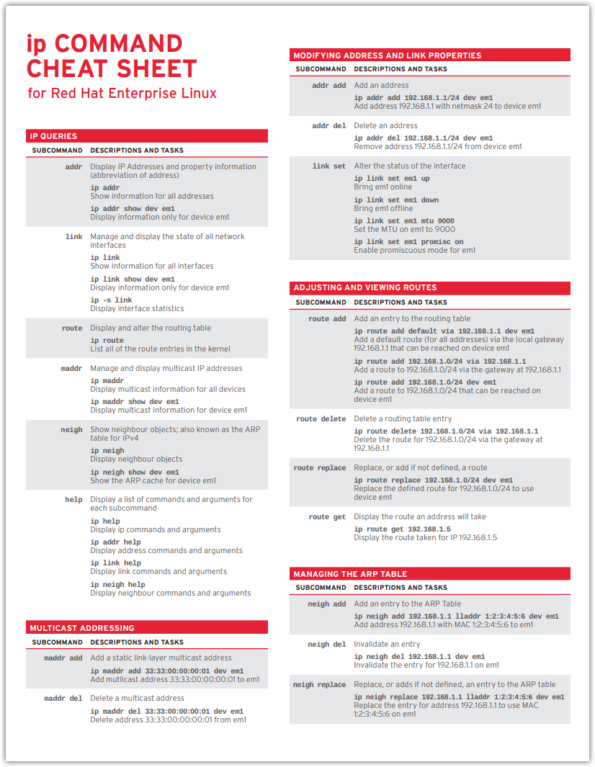
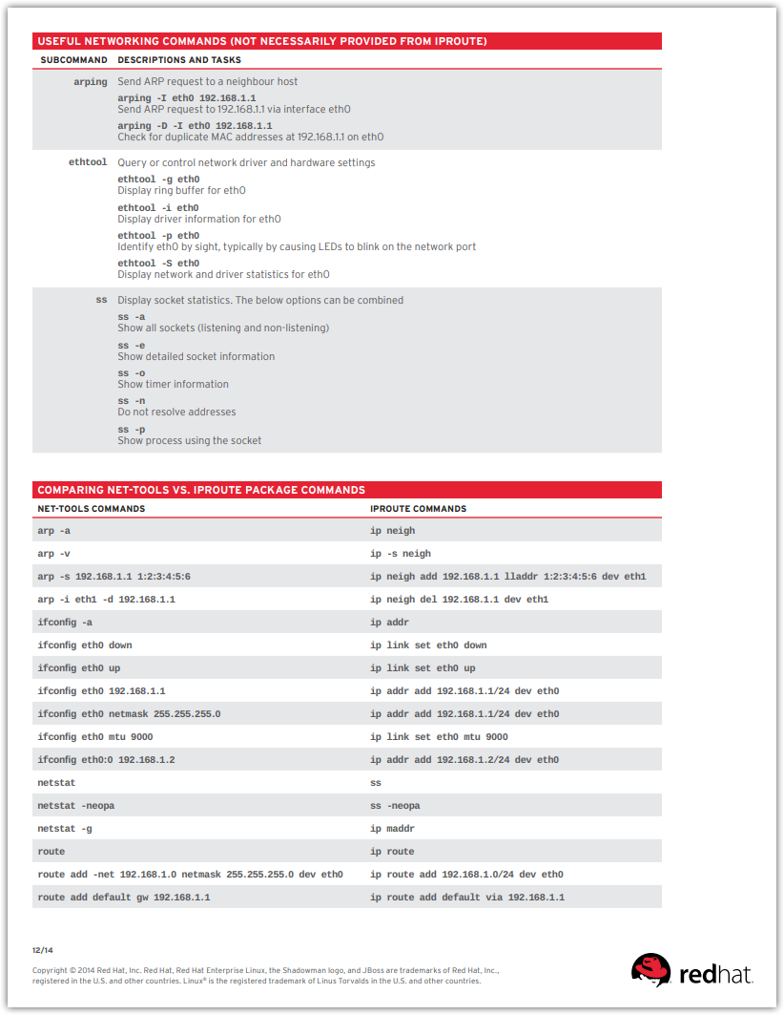

#
# How to remove, disable, down team interface on Centos 7.
#
# https://www.2daygeek.com/enable-disable-up-down-nic-network-interface-port-linux-using-ifconfig-ifdown-ifup-ip-nmcli-nmtui/
# https://access.redhat.com/documentation/en-us/red_hat_enterprise_linux/7/html/networking_guide/sec-configure_a_network_team_using-the_command_line
# https://access.redhat.com/documentation/en-us/red_hat_enterprise_linux/7/html/networking_guide/sec-controlling_teamd_with_teamdctl
#

# Here is how to see all network config files and their names.
[root@ds-asterisk-str02p ~]# for var1 in $(find /etc/sysconfig/network-scripts/ \( -name ifcfg-\* -o -name route\* \) | sort) ; do echo ; echo $var1 ; cat $var1
; done

# It’s just for information - that this command exists. It was not useful for me.
[root@ds-asterisk-str02p ~]# teamdctl team0 state view
setup:
runner: activebackup
ports:
em2
link watches:
link summary: up
instance[link_watch_0]:
name: ethtool
link: up
down count: 0
runner:
active port: em2
[root@ds-asterisk-str02p ~]#

# This commnad didn’t help me. Here in option present “dev”.
[root@ds-asterisk-str02p ~]# ip link set dev team0.1765 down

# This command didn’t work at all and generate error. Perhaps it’s require NetworkManager to be run.
[root@ds-asterisk-str02p ~]# ifdown team0.1994
libteamdctl: cli_usock_process_msg: usock: Error message received: "NoSuchDev"
libteamdctl: cli_usock_process_msg: usock: Error message content: "No such device."
command call failed (Invalid argument)
[root@ds-asterisk-str02p ~]#

# This commnad didn’t help me.
[root@ds-asterisk-str02p ~]# ifconfig team0.1765 down

# To use nmcli commnads - require to start NetworkManager.
[root@ds-asterisk-str02p ~]# nmcli con show
Error: NetworkManager is not running.
[root@ds-asterisk-str02p ~]#

[root@ds-asterisk-str02p ~]# systemctl status NetworkManager
● NetworkManager.service - Network Manager
Loaded: loaded (/usr/lib/systemd/system/NetworkManager.service; disabled; vendor preset: enabled)
Active: inactive (dead)
Docs: man:NetworkManager(8)
[root@ds-asterisk-str02p ~]# systemctl start NetworkManager
[root@ds-asterisk-str02p ~]# systemctl status NetworkManager
● NetworkManager.service - Network Manager
Loaded: loaded (/usr/lib/systemd/system/NetworkManager.service; disabled; vendor preset: enabled)
Active: active (running) since Wed 2020-11-25 16:48:28 MSK; 3s ago
Docs: man:NetworkManager(8)
Main PID: 95071 (NetworkManager)
CGroup: /system.slice/NetworkManager.service
└─95071 /usr/sbin/NetworkManager --no-daemon

Nov 25 16:48:29 ds-asterisk-str02p.tcsbank.ru NetworkManager[95071]: <info> [1606312109.4504] device (em1): Activation: starting connection 'team0 sl...8d23a7)
Nov 25 16:48:29 ds-asterisk-str02p.tcsbank.ru NetworkManager[95071]: <info> [1606312109.4507] device (em1): state change: disconnected -> prepare (re...0 40 0]
Nov 25 16:48:29 ds-asterisk-str02p.tcsbank.ru NetworkManager[95071]: <info> [1606312109.4512] device (em1): state change: prepare -> config (reason '...0 50 0]
Nov 25 16:48:29 ds-asterisk-str02p.tcsbank.ru NetworkManager[95071]: <info> [1606312109.4523] device (em1): state change: config -> ip-config (reason...0 70 0]
Nov 25 16:48:29 ds-asterisk-str02p.tcsbank.ru NetworkManager[95071]: <info> [1606312109.8166] device (team0): enslaved team port em1
Nov 25 16:48:29 ds-asterisk-str02p.tcsbank.ru NetworkManager[95071]: <info> [1606312109.8166] device (em1): Activation: connection 'team0 slave 1' en...ivation
Nov 25 16:48:29 ds-asterisk-str02p.tcsbank.ru NetworkManager[95071]: <info> [1606312109.8173] device (em1): state change: ip-config -> secondaries (r...0 90 0]
Nov 25 16:48:29 ds-asterisk-str02p.tcsbank.ru NetworkManager[95071]: <info> [1606312109.8181] device (em1): state change: secondaries -> activated (r... 100 0]
Nov 25 16:48:29 ds-asterisk-str02p.tcsbank.ru NetworkManager[95071]: <info> [1606312109.8190] device (em1): Activation: successful, device activated.
Nov 25 16:48:30 ds-asterisk-str02p.tcsbank.ru NetworkManager[95071]: <info> [1606312110.1137] device (em1): link connected
Hint: Some lines were ellipsized, use -l to show in full.
[root@ds-asterisk-str02p ~]#

[root@ds-asterisk-str02p ~]# ip a | grep -w inet
inet 127.0.0.1/8 scope host lo
inet 10.216.106.106/24 brd 10.216.106.255 scope global team0.2906
inet 10.217.65.191/24 brd 10.217.65.255 scope global team0.1765
inet 10.217.165.130/24 brd 10.217.165.255 scope global team0.2765
inet 10.219.94.14/24 brd 10.219.94.255 scope global team0.1994
[root@ds-asterisk-str02p ~]# nmcli con show
NAME UUID TYPE DEVICE
Team connection 1 51f140ff-877e-4061-b369-8015fa7f3386 team team0
VLAN connection 3 f6a7340d-d2ce-d3b9-b15f-daa6299e2210 vlan team0.2765
team0 slave 1 acf22910-0576-4eb4-9888-3032198d23a7 802-3-ethernet em1
team0 slave 2 fa1bf19d-fc27-4a33-994c-b1dbb46835f6 802-3-ethernet em2
team0.2906 4f112e2a-3812-471e-b468-ede8aaeb9ddf vlan team0.2906
VLAN connection 1 be83fd3d-665e-484f-9e9e-2cafe8a55ebb vlan --
VLAN connection 2 710a9a10-4540-b9aa-b33c-9b84ce89bcb2 vlan --
VLAN2906 a0ad415a-f26b-d425-0fe1-cac009766235 vlan --
em1 b4fe02a2-d84b-4543-b5c7-8ebe81d478b0 802-3-ethernet --
em2 72a6b8aa-f66c-4d63-9a4c-f9eaa83effb3 802-3-ethernet --
em3 1424dd78-ba4e-4b8e-902c-4aa0730bab06 802-3-ethernet --
em4 3cb2805a-103b-4bc0-aec4-de8877657700 802-3-ethernet --
[root@ds-asterisk-str02p ~]#

# This command helped me.
[root@ds-asterisk-str02p ~]# nmcli con down 'VLAN connection 3'
Connection 'VLAN connection 3' successfully deactivated (D-Bus active path: /org/freedesktop/NetworkManager/ActiveConnection/3)
[root@ds-asterisk-str02p ~]# ip a | grep -w inet
inet 127.0.0.1/8 scope host lo
inet 10.216.106.106/24 brd 10.216.106.255 scope global team0.2906
inet 10.217.65.191/24 brd 10.217.65.255 scope global team0.1765
inet 10.219.94.14/24 brd 10.219.94.255 scope global team0.1994
[root@ds-asterisk-str02p ~]#

# This command didn’t help me. This interface already recognized as turned off.
[root@ds-asterisk-str02p ~]# nmcli con down 'VLAN connection 2'
Error: 'VLAN connection 2' is not an active connection.
Error: no active connection provided.
[root@ds-asterisk-str02p ~]#

# This command didn’t help me
[root@ds-asterisk-str02p ~]# ip link set team0.1765 down
[root@ds-asterisk-str02p ~]# ip a | grep -w inet
inet 127.0.0.1/8 scope host lo
inet 10.216.106.106/24 brd 10.216.106.255 scope global team0.2906
inet 10.217.65.191/24 brd 10.217.65.255 scope global team0.1765
inet 10.219.94.14/24 brd 10.219.94.255 scope global team0.1994
[root@ds-asterisk-str02p ~]#

# This command didn’t help me.
[root@ds-asterisk-str02p ~]# ifdown team0.1765
Device 'em1' successfully disconnected.
[root@ds-asterisk-str02p ~]# ip a | grep -w inet
inet 127.0.0.1/8 scope host lo
inet 10.216.106.106/24 brd 10.216.106.255 scope global team0.2906
inet 10.217.65.191/24 brd 10.217.65.255 scope global team0.1765
inet 10.219.94.14/24 brd 10.219.94.255 scope global team0.1994
[root@ds-asterisk-str02p ~]#

[root@ds-asterisk-str02p ~]# nmcli con show
NAME UUID TYPE DEVICE
Team connection 1 51f140ff-877e-4061-b369-8015fa7f3386 team team0
team0 slave 2 fa1bf19d-fc27-4a33-994c-b1dbb46835f6 802-3-ethernet em2
team0.2906 4f112e2a-3812-471e-b468-ede8aaeb9ddf vlan team0.2906
VLAN connection 1 be83fd3d-665e-484f-9e9e-2cafe8a55ebb vlan --
VLAN connection 2 710a9a10-4540-b9aa-b33c-9b84ce89bcb2 vlan --
VLAN connection 3 f6a7340d-d2ce-d3b9-b15f-daa6299e2210 vlan --
VLAN2906 a0ad415a-f26b-d425-0fe1-cac009766235 vlan --
em1 b4fe02a2-d84b-4543-b5c7-8ebe81d478b0 802-3-ethernet --
em2 72a6b8aa-f66c-4d63-9a4c-f9eaa83effb3 802-3-ethernet --
em3 1424dd78-ba4e-4b8e-902c-4aa0730bab06 802-3-ethernet --
em4 3cb2805a-103b-4bc0-aec4-de8877657700 802-3-ethernet --
team0 slave 1 acf22910-0576-4eb4-9888-3032198d23a7 802-3-ethernet --
[root@ds-asterisk-str02p ~]#

[root@ds-asterisk-str02p ~]# ip a
1: lo: <LOOPBACK,UP,LOWER_UP> mtu 65536 qdisc noqueue state UNKNOWN qlen 1
link/loopback 00:00:00:00:00:00 brd 00:00:00:00:00:00
inet 127.0.0.1/8 scope host lo
valid_lft forever preferred_lft forever
inet6 ::1/128 scope host
valid_lft forever preferred_lft forever
2: em3: <NO-CARRIER,BROADCAST,MULTICAST,UP> mtu 1500 qdisc mq state DOWN qlen 1000
link/ether 24:6e:96:55:2e:44 brd ff:ff:ff:ff:ff:ff
3: em1: <BROADCAST,MULTICAST,UP,LOWER_UP> mtu 9000 qdisc mq state UP qlen 1000
link/ether 24:6e:96:55:2e:40 brd ff:ff:ff:ff:ff:ff
4: em4: <NO-CARRIER,BROADCAST,MULTICAST,UP> mtu 1500 qdisc mq state DOWN qlen 1000
link/ether 24:6e:96:55:2e:45 brd ff:ff:ff:ff:ff:ff
5: em2: <BROADCAST,MULTICAST,UP,LOWER_UP> mtu 9000 qdisc mq master team0 state UP qlen 1000
link/ether 24:6e:96:55:2e:40 brd ff:ff:ff:ff:ff:ff
16: team0: <BROADCAST,MULTICAST,UP,LOWER_UP> mtu 9000 qdisc noqueue state UP qlen 1000
link/ether 24:6e:96:55:2e:40 brd ff:ff:ff:ff:ff:ff
inet6 fe80::266e:96ff:fe55:2e40/64 scope link
valid_lft forever preferred_lft forever
17: team0.2906@team0: <BROADCAST,MULTICAST,UP,LOWER_UP> mtu 9000 qdisc noqueue state UP qlen 1000
link/ether 24:6e:96:55:2e:40 brd ff:ff:ff:ff:ff:ff
inet 10.216.106.106/24 brd 10.216.106.255 scope global team0.2906
valid_lft forever preferred_lft forever
inet6 fe80::266e:96ff:fe55:2e40/64 scope link
valid_lft forever preferred_lft forever
18: team0.1765@team0: <BROADCAST,MULTICAST> mtu 9000 qdisc noqueue state DOWN qlen 1000
link/ether 24:6e:96:55:2e:40 brd ff:ff:ff:ff:ff:ff
inet 10.217.65.191/24 brd 10.217.65.255 scope global team0.1765
valid_lft forever preferred_lft forever
19: team0.2765@team0: <BROADCAST,MULTICAST,UP,LOWER_UP> mtu 9000 qdisc noqueue state UP qlen 1000
link/ether 24:6e:96:55:2e:40 brd ff:ff:ff:ff:ff:ff
20: team0.1994@team0: <BROADCAST,MULTICAST> mtu 9000 qdisc noqueue state DOWN qlen 1000
link/ether 24:6e:96:55:2e:40 brd ff:ff:ff:ff:ff:ff
inet 10.219.94.14/24 brd 10.219.94.255 scope global team0.1994
valid_lft forever preferred_lft forever
[root@ds-asterisk-str02p ~]# ip addr del 10.217.65.191/24 dev team0.1765
[root@ds-asterisk-str02p ~]# ip a | grep -w inet
inet 127.0.0.1/8 scope host lo
inet 10.216.106.106/24 brd 10.216.106.255 scope global team0.2906
inet 10.219.94.14/24 brd 10.219.94.255 scope global team0.1994
[root@ds-asterisk-str02p ~]# ip addr del 10.219.94.14/24 dev team0.1994
[root@ds-asterisk-str02p ~]# ip a | grep -w inet
inet 127.0.0.1/8 scope host lo
inet 10.216.106.106/24 brd 10.216.106.255 scope global team0.2906
[root@ds-asterisk-str02p ~]#

#
# 20210318
#

#
# Changing MTU can broke network connection and made server hangs.
# It safer to make changes during network connection already down. And after changes - up it.
#
https://www.cyberciti.biz/faq/centos-rhel-redhat-fedora-debian-linux-mtu-size/
...
ip link set eth0 mtu 9000
ip link set eth0 up

